**Walchand College of Engineering, Sangli Department of Computer Science and Engineering**

Third Year – Programming Laboratory-3 (2020-21)

Practical No. 7C – T8 Batch

To design and develop web pages using HTML Multimedia elements.

**PRN: 2018BTECS00045**

Git Repository: <https://github.com/Apurva0707/PL3_lab_2018btecs00045>

Problem Statement 1:

Design a HTML web page that satisfies the following requirements. Access it locally and in LAN using a web server.

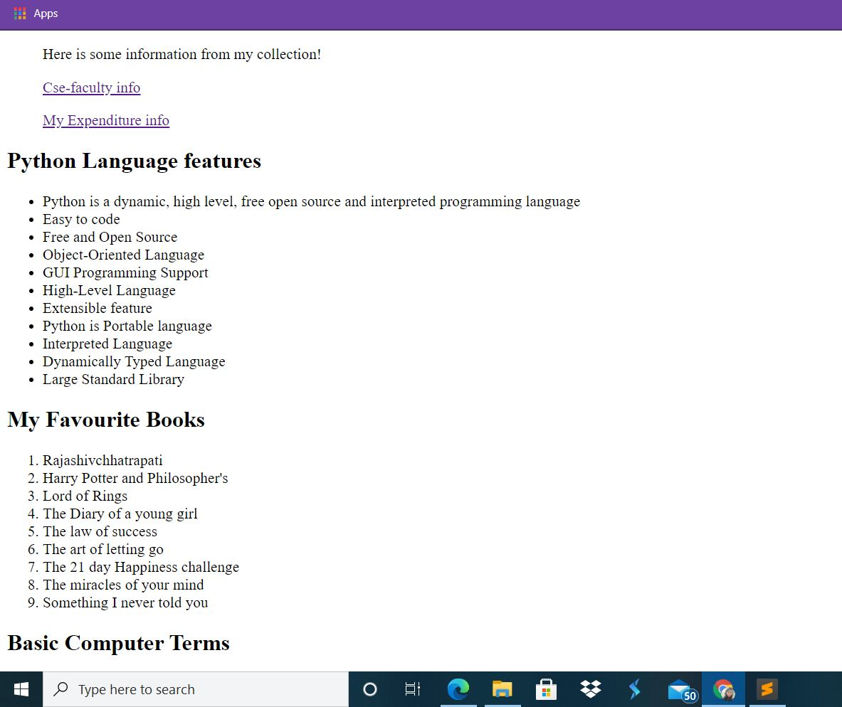

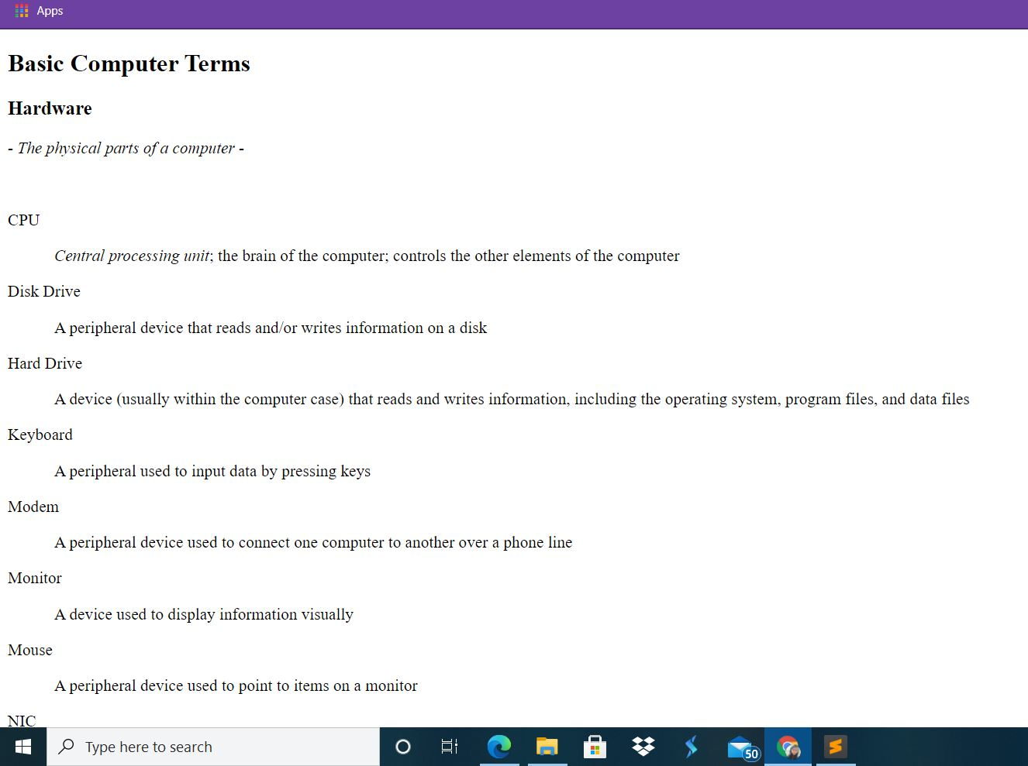

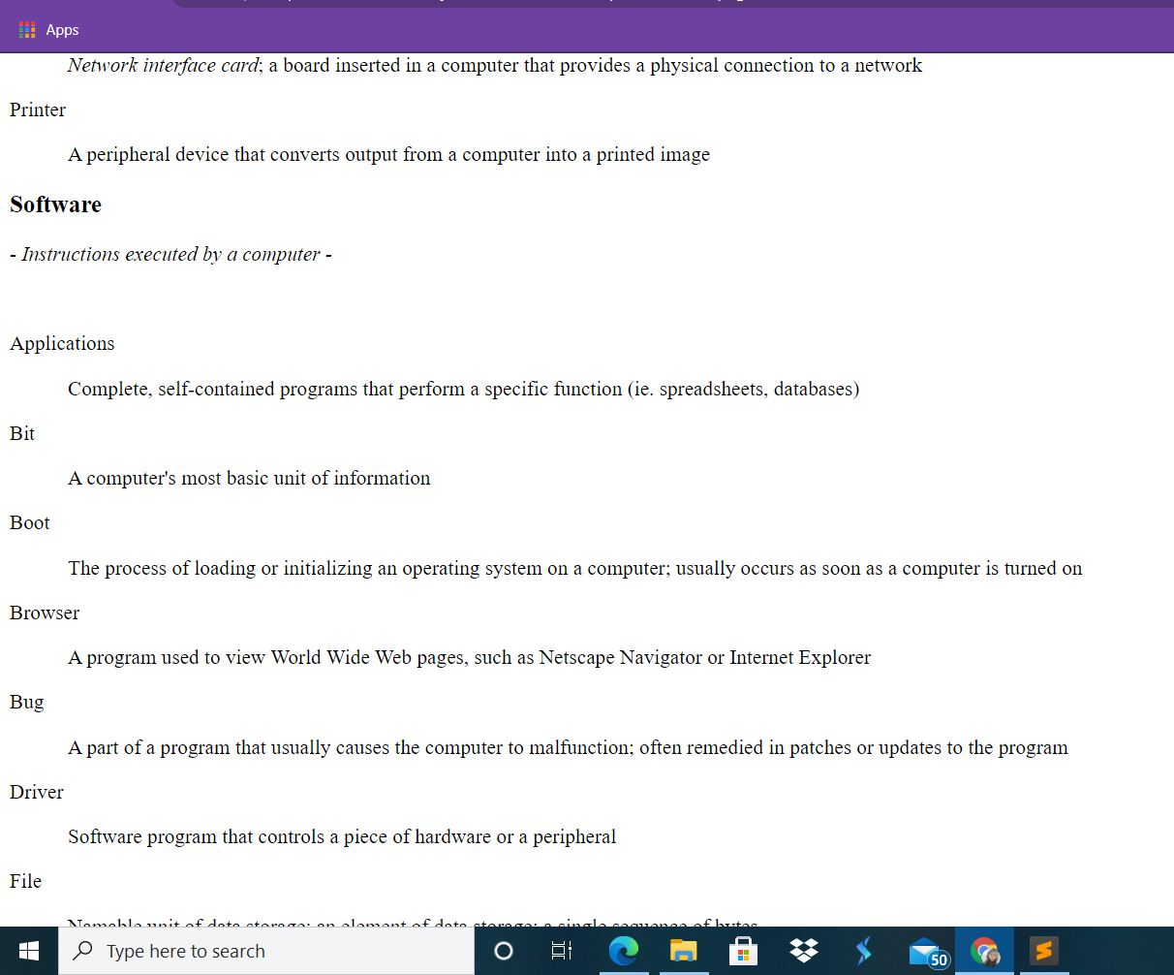

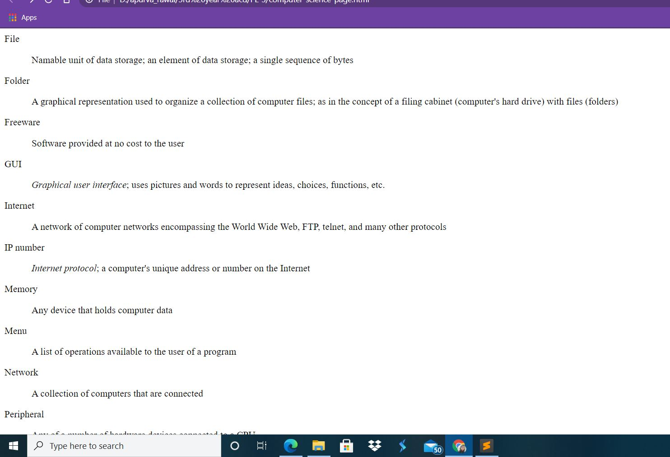

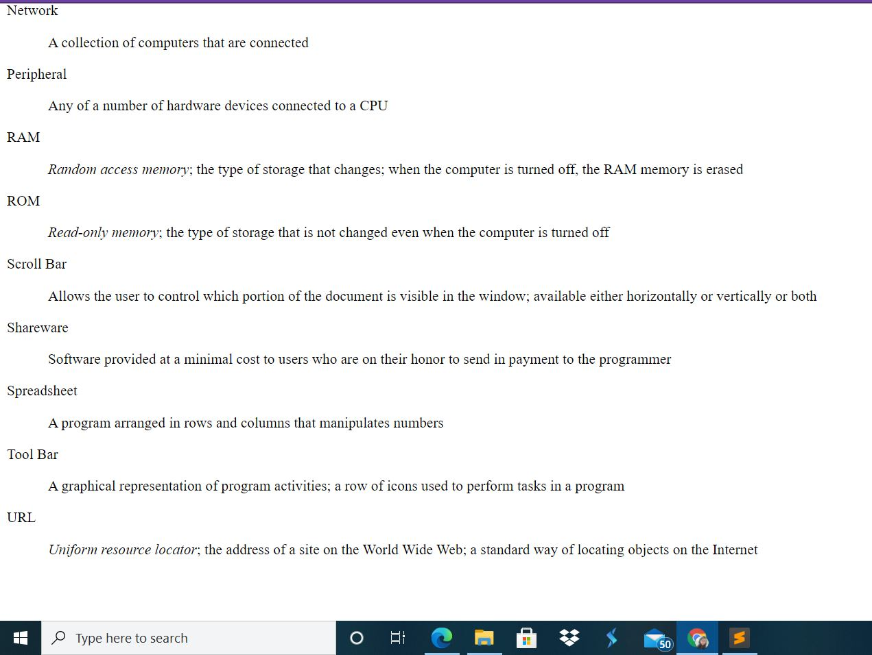

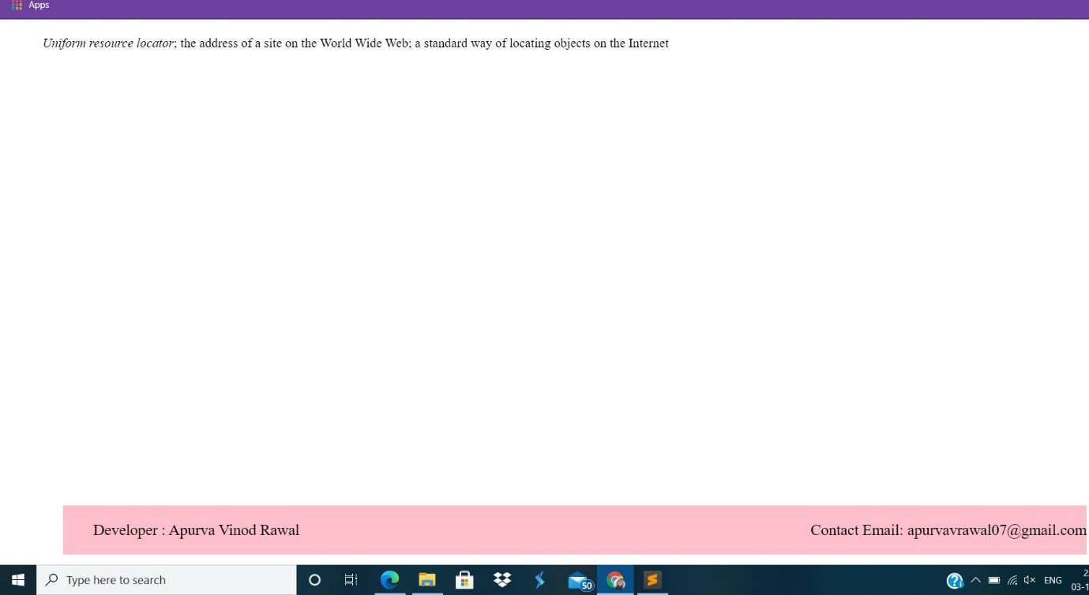

Problem Statement 2:

Design a HTML web page that displays CSE faculty information in tabular form. Access it locally and in LAN using a web server.

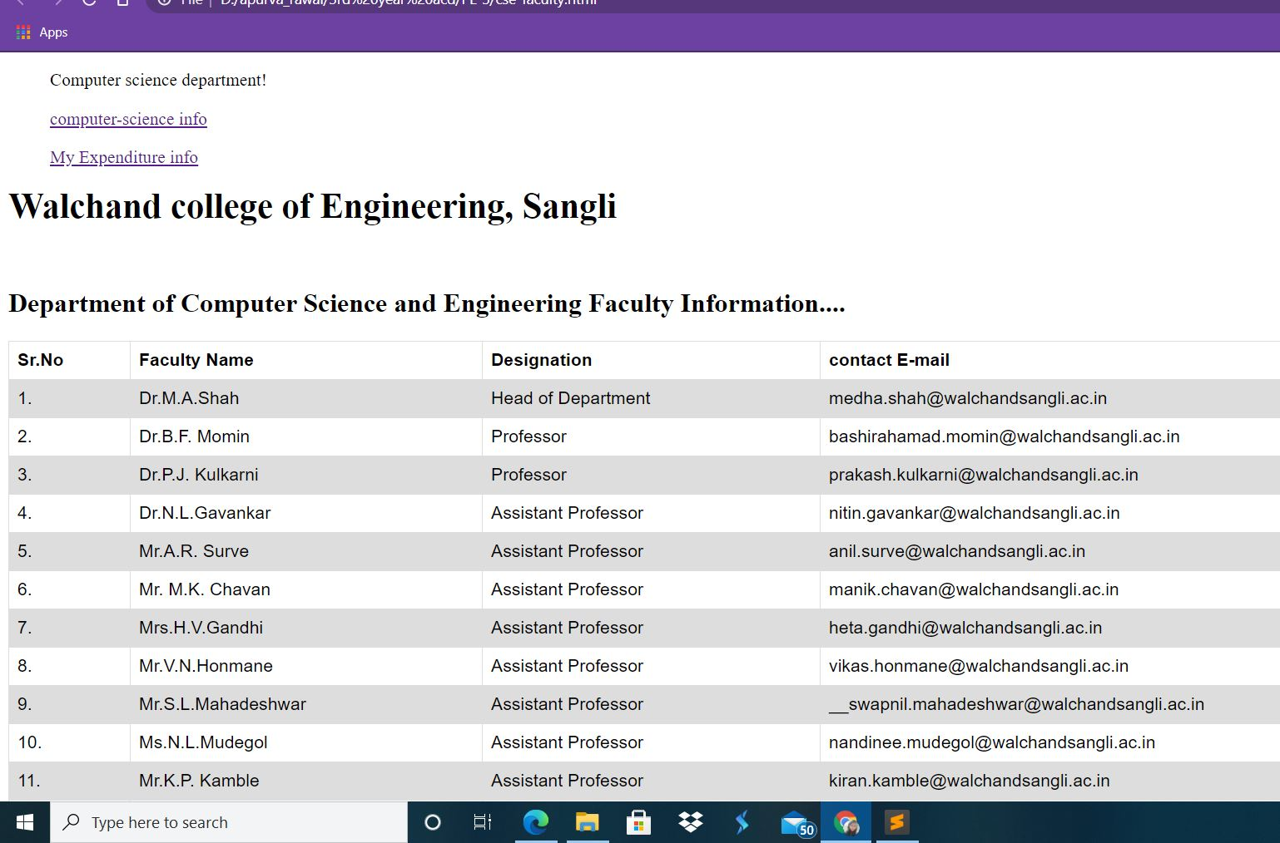

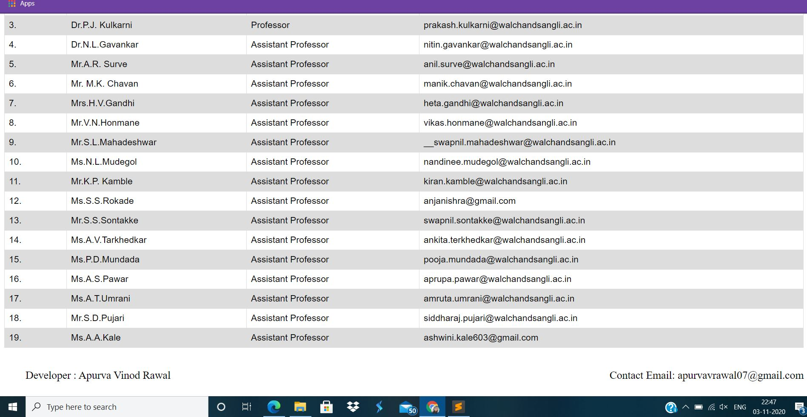

Problem Statement 3:

Design a HTML web page that displays Your monthly expense in tabular form. Access it locally and in LAN using a web server.

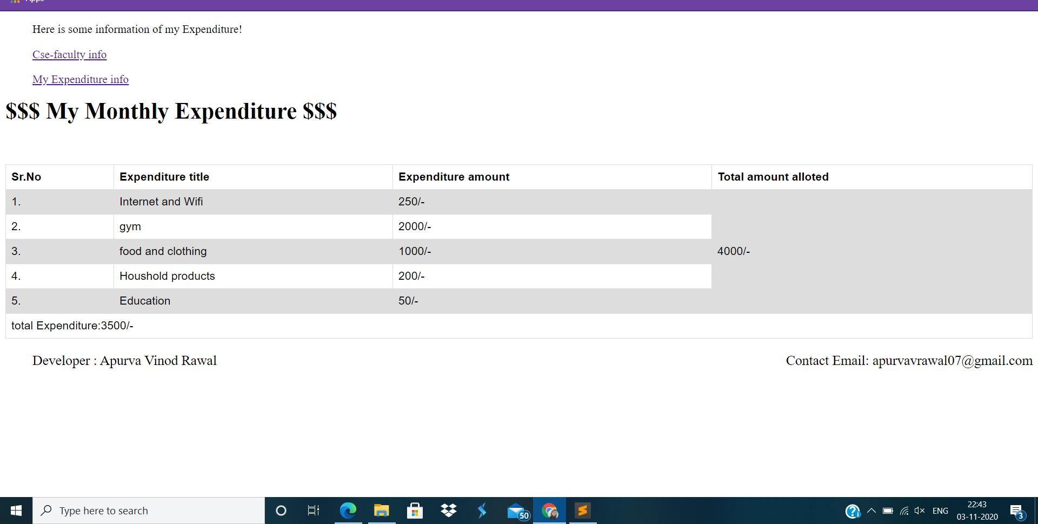

Problem Statement 4:

For all the above stated problem statements, perform HTML validation using <https://validator.w3.org/> and take appropriate actions.

